**90949010 & 90949118 FRU Transporter Pre-install Procedure**

Doc #90940076 Rev. C

**Purpose**

This document is to be used by Field Service personnel when replacing a FRU transporter at a customer site. The intent is to reduce replacement time due to service checks required on this assembly prior to installation.

**Process**

Prior to installing the transporter FRU, the following inspection checklist should be completed. This is to ensure that the transporter has not undergone any physical changes during handling and shipment. Please indicate any items identified in the notes section below.

***Return this completed page 1 of this checklist with the returning transporter to Spectra Logic. Electronic versions of this document may be submitted to*** [***support@spectralogic.com***](mailto:support@spectralogic.com) ***with the Spectra Logic service incident number included in the subject line.***

Replacement Transporter SN: TRN  EC Level:   
Date of Service / Inspection: 

Spectra Logic service Incident number: 

Transporter FRU manufacturing bar code

Added as applicable

Field Personnel performing verification: 

|  |  |  |  |
| --- | --- | --- | --- |
| **Verification check** | **Pass** | **Fail** | **Notes** |
| 1. Packaging arrived undamaged with extended cutout section in foam   (reference foam insert illustration #1) |  |  |  |
| 2. SAX cable connection verified  (reference SAX cable illustration #2) |  |  |  |
| 3. MAX cable connection verified  (reference MAX cable illustration #3) |  |  |  |
| 4. MAX & SAX gears all circlips, gears and bearings in place  (reference gear illustration #4) |  |  |  |
| 5. Barcode reader flex cable connection  (reference gear illustration #) |  |  |  |
| 6. Solenoid roll pin orientation  (reference solenoid roll pin illustration #6) |  |  |  |

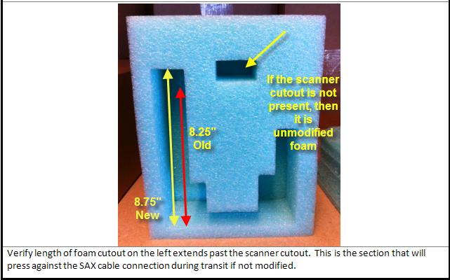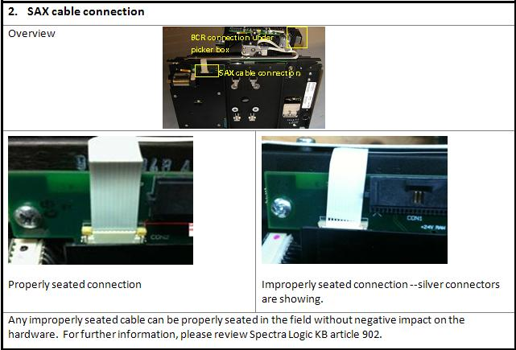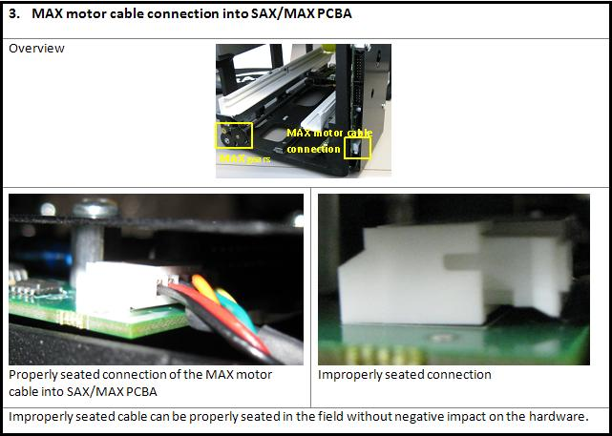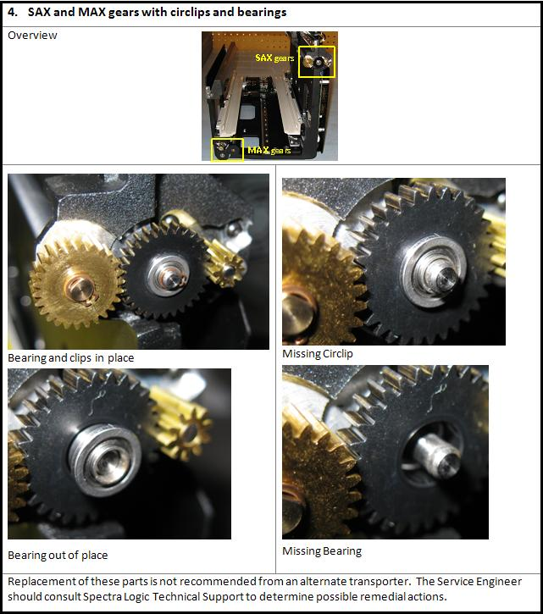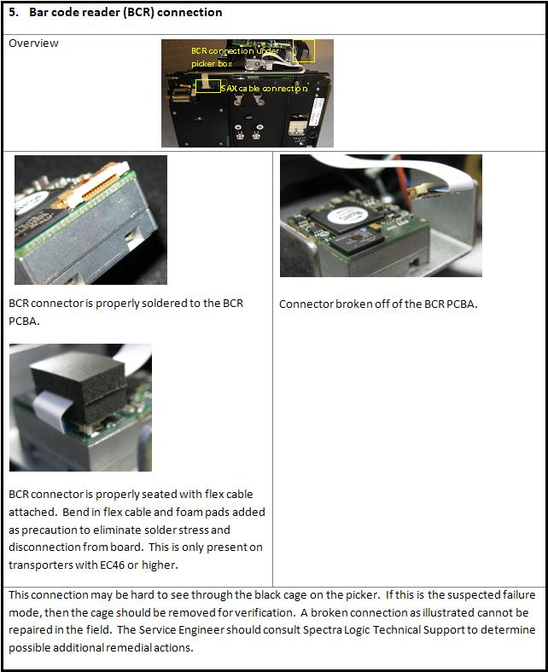

*(Present only on transporters below EC60.)*

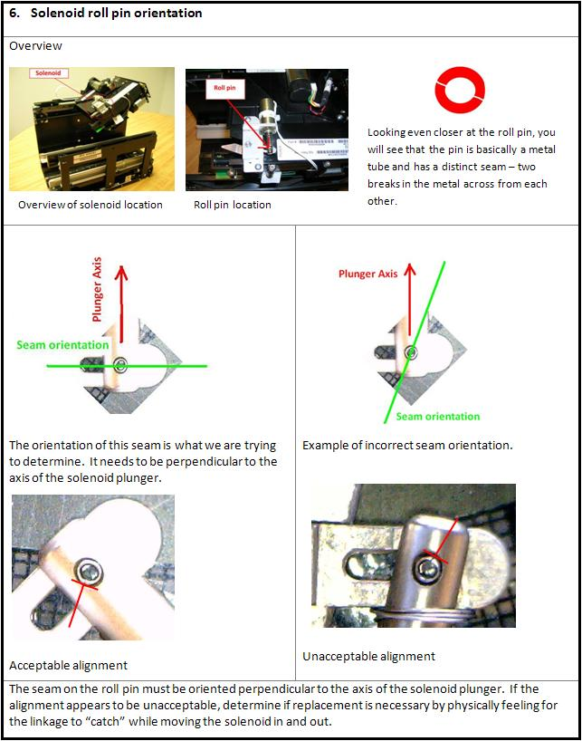

**Revision History**

|  |  |  |  |
| --- | --- | --- | --- |
| **Date:** | **Revision:** | **Explanation:** | **Implemented by:** |
| 1/4/11 | A | Original document | LeanneD |
| 2/25/11 | B | Included solenoid roll pin orientation verification. | LeanneD |
| 6/26/12 | C | Added, “(Present only on transporters below EC60.)” to “6. Solenoid roll pin orientation” on page 6. Also added “EC Level” field on page 1. | HeatherA |